|  |  |  |  |  |  |
| --- | --- | --- | --- | --- | --- |
|  |  | | | | |
|  | |  | | | |
| Project: | | Personal Tutoring Service  CSE 5325 – Fall 2013  Project Management | | | |
| Module: | | Project Scope & Feasibility | | | |
| Deliverable: | | Scope & Feasibility Document | | | |
| Version: | | | [1.0] | Date: | [09/23/2013] |

Prepared by: Akshay Mattoo: 1000995551

Revision History

| Version number | Date | Originator | Reason for change | High level description of changes |
| --- | --- | --- | --- | --- |
| 1.0 | 09/23/2013 | Akshay Mattoo | Initial draft |  |
|  |  |  |  |  |
|  |  |  |  |  |

TABLE OF CONTENTS

1. Introduction and Executive Summary 3

2. Objectives 4

2.1 BUSINESS Objectives 4

2.2 SYSTEM Objectives 4

3 Project Feasibility, Risks and Metrics 5

3.1 Project Feasibility Concerns 5

3.2 Project Risks 5

3.3 Project Metrics 5

4 Project Scope and Process Model 6

4.1 Project Process Model 6

4.2 Project Context 7

5. Assumptions and Constraints 8

5.1 ASSUMPTIONS 8

5.2 CONSTRAINTS 8

6. Project Tasks, Schedule and Cost 9

7. Conclusion and Recommendations 10

Appendices 11

# 1. Introduction and Executive Summary

Personal tutoring service is an android based app which helps students to search for a tutor and the helps the tutor to market his/her skills. With the proper search criteria and the google maps being integrated in the app one can find a tutor. One can register or can enter as a guest user to search for the tutor. Once logged in a student can rate a professor on certain skills and that in turn can help the other incoming students judge the professor better. Notifications is also being integrated through emails, so that communications being there in between the interested users.

Below diagram shows the application framework.

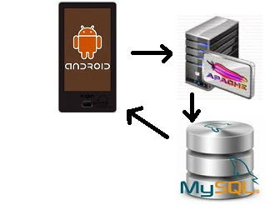

# 2. Objectives

## 2.1 BUSINESS Objectives

The following is the list of business objectives:

Login/Register: The landing page will be a login/register page which lets the user to login if already a member or register if want to register as a tutor or student.

Search: If logged in as a student, he/she can search for the tutor and can see the directions using the google maps.

Feedback: Student has an option to review a tutor, based on the helpfulness, knowledge and many more things and a text box to give additional comments if the student wants to.

Notifications: Notification module helps both student as well as the tutor to get the notifications about each other. The communication is by email.

Advertisement: A tutor can advertise the skills.

## 2.2 SYSTEM Objectives

The following is the list of system objectives:

Objective 1: Project will be a mobile app based on the android platform.

Objective 2: Google maps will be integrated into the system for the directions to locate the tutor.

Objective 3: Database is required to store all the information about the students and the tutor. Search made will be stored to make the system user friendly as the user can see the previously searched queries.

Objective 4: Sever is required to host the database and the apache serve.

Objective 5: Notification module needs to access internet on the device to send the notification.

# 3 Project Feasibility, Risks and Metrics

## 3.1 Project Feasibility Concerns

The feasibility is explained under three divisions listed below.

Operational Feasibility: In the first release the maintenance would not be the part. In the second release the maintenance would be included with some added features.

Technical Feasibility: Firstly App should be version compatible for the android system. Secondly the development has to be done in such a manner that we have to incorporate the different sizes of all the android devices present in the market. Thirdly will have to look into the memory allocation, battery, is the app making the use of phone resources properly or not, in the development phase only.

Economic feasibility:System development is the one time cost and annual operating cost is the ongoing cost. The software being made should definitely yield benefits. Comparing the benefit dollars to the cost dollars, one can tell if the proposed information system is going to break even, cost the business, or save the business money. Once a project is started, financial analyses should continue to be done at periodic intervals to determine if the information system still makes economic sense.

## 3.2 Project Risks

Below are the risks involved in the project.

* If a member from one team who is the most skilled in one domain leaves then to find the replacement can be a tough job. So to mitigate it we need to keep the knowledge transfer sessions once in a week so that all will be familiar with the things going on in the project. For e.g. a database software engineer leaves in the middle of the project then project can get affected, but if the proper knowledge transfer sessions are being put in the project then anyone from the project can pull on and keep the work going on. Or the other option can be paring the employees.
* Depending upon the response of the application from users, we might need to modify the marketing strategies to launch the app if the feedback is not so good.
* If there are some changes in the requirements during the build phase then the working copy of the project is maintained in the configuration manager and the changes will be done on other branch.

Above are the risks identified at the project starting phase .In the table below we will manage all the risks that we are facing at the time of execution.

|  |  |  |  |  |
| --- | --- | --- | --- | --- |
| Id | Risk description | Priority | Mitigation | Owner |
|  |  |  |  |  |

## 3.3 Project Metrics

The metrics of success is the simplicity of the project and solving the problems at one go. The number of downloads and the number of users who are using the app makes the difference. To have the maximum of these two factors proper metrics is to be followed. Below is the list of metrics that we would concentrate on.

* **Time**– We will keep track of time how the team is performing for the given tasks.
* **Cost** – During the course of project we will keep track of budget to see if we on track and not over budgeting.
* [Milestones](http://www.brighthubpm.com/methods-strategies/5871-a-lecture-on-project-management-basics/) – Milestones would be defined in order to note the progress and see if the team is in need of any resource if the mile stone is no met. Helps keeping track of schedule as well.
* **Status of Deliverables** – This includes to record the date of delivery of related documents, the internal release of the project in pieces etc. Matching the date of deliverables with the proposed on and keeping track of everything.
* Customer Feedback – Input from the customer, if they are happy using it or some modifications are required to make it a better and more useful app for them.

# 4 Project Scope and Process Model

Project scope includes the following:

1. Help documents having the flow how to use the app with proper screen shots.
2. The project will be delivered by second week of November.
3. Project will be developed and tested in phases and the final product will be launched. No in between releases for the public use. Internal release would be there to keep track of the project.

The following is a list of items out of scope:

1. A release of new version of android while the app is in the development phase.
2. A new device with new dimension gets launched in the market while the app is still in the building progress for some dimensions.
3. While signing up user puts the wrong info .No method to cross verify the data.

## 4.1 Project Process Model

In this project we will be using agile methodology. An agile methodology accelerates the development activity and helps to identify the proper loop holes in the need for integration of both tools and people working on the project. To help ensure the efficient development of project the matrices are to be met. All changes—to code, project status, and assignments and so on—need to be tracked and made visible to everyone in the team. The transparency helps each and every to know about the whole project. The below diagrams illustrates the life cycle.

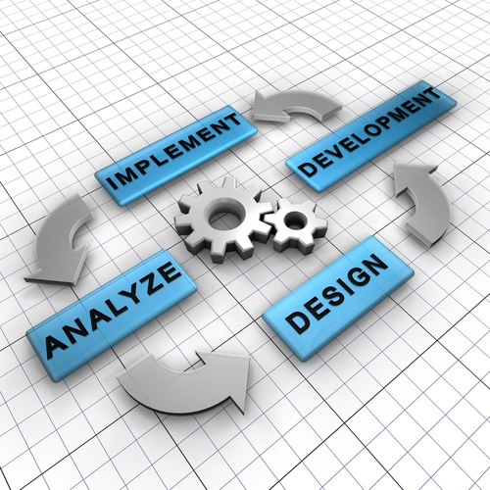

## 4.2 Project Context

Below diagram shows all the components in the project.

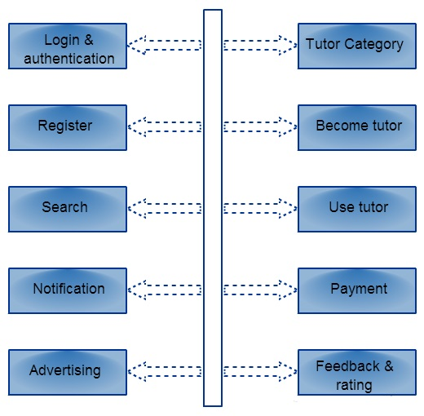

# 5. Assumptions and Constraints

## 5.1 ASSUMPTIONS

The following is a list of assumptions:

* User will understand the flow with the help of documents provided with the app.
* User is giving the right information while signing up, such as email, address etc.

## 5.2 CONSTRAINTS

The following is a list of constraints:

* Cannot use google maps if the internet is not working on the device.
* Notification module will not work if the device is not connected to the internet.

# 6. Project Tasks, Schedule and Cost

Below is the embedded document for the screen shots of the project planner.



# 7. Conclusion and Recommendations

The shift of trend in computing from Pc’s to laptop to smart phones and tablets made us to build the application on android platform which is an open source platform. The benefit of this app would be one can do things on the go. In the second release more features like comparing two professors on certain criteria’s, more interactive user interface to make the application more user friendly and more security features will be added.

# Appendices

To get an overview of android and agile development for mobile development below are the respective reference links.

<http://www.android.com/about/>

<https://www.ibm.com/developerworks/community/blogs/c914709e-8097-4537-92ef-8982fc416138/entry/agile_for_mobile_development113?lang=en>